52nd Symposium of Computer Applications in Archaeology 2025:

Digital horizons: embracing heritage in an evolving world

**Manon Vuillien1, Vanna Lisa Coli2, Pauline Garberi3**

1 Archaeozoologist, Post-doctorante fellowship at Côte d’Azur University, CEPAM UMR 7264, Nice

2 Junior Fellow in Artificial Intelligence, University of French Riviera, Nice, France

3 Statistical and scientific computing engineer, at Côte d’Azur University, CNRS, CEPAM UMR 7264, Nice

Deadline for call papers: **29 October 🡪 EXTENSION: 24 November**

Registration here: <https://2025.caaconference.org/call-for-papers/>

**Standard session**

Digital bioarcheology: new approaches for old problems

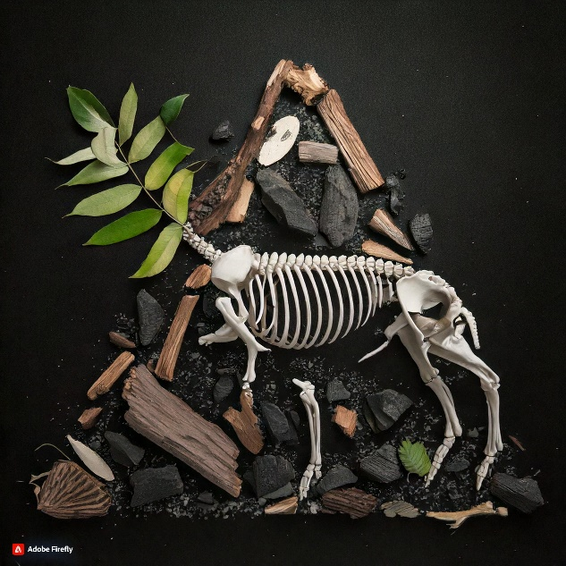

Studying the diversity of living and fossilised organisms in biology and palaeontology is inextricably linked to the work of mathematicians. Since the ground-breaking work of the zoologist and mathematician D'Arcy Thompson at the beginning of the 20th century, there have been significant advances in the methodology used to study the variability of biological forms due to the integration of geometric perspectives (Bookstein, 1978; 1996). The rise of computational methods in shape analysis combined with the widespread use of 3D imaging in the 1990s has enabled new and innovative advancements in the analysis and virtual recognition of biological forms.

The use of computational techniques in the analysis of biological archives (faunal and botanical remains) from archaeological contexts is a relatively recent phenomenon. This could be attributed to several factors. Firstly, the intrinsic characteristics of bioarchaeological remains give rise to various complications and present specific difficulties. The deployment of computational quantitative approaches is highly dependent on the availability of large amounts of comparable digital data in 2D or 3D. However, these data are frequently inaccessible. Secondly, the preservation of faunal and botanical remains is rarely optimal due to their original function (e.g. food waste) and the conditions under which they were buried, found and stored. Thirdly, the *inter*- and *intra*-individual variability of past plants and animals is based on partial data that are often challenging to compare with current data. In light of these challenges, it is crucial to integrate the expertise of bioarcheologists with machine learning and statistical methods. In that sense, the application of supervised and unsupervised machine learning techniques, as demonstrated by studies such as those of Miele *et al.* (2020) and Bonhomme *et al.* (2023), was helping to address current biosocial questions such as the domestication process and biogeographic history of mammals, as well as the dynamics of human settlements and their role in the emergence of commensal animals and the evolution of terrestrial ecosystems. A larger involvement of applied mathematics experts into interdisciplinary works on bioarchaeology questions will assure steady advancements to both disciplines.

The goal of this session is to bring together, for the first time, interdisciplinary research led by bioarchaeologists and mathematicians. This session will explore how the use of machine learning techniques has been integrated into studies of faunal and plant remains to improve our understanding of human-nature interaction over long periods of time. Expected contributions to this session will include works on:

* Supervised or unsupervised learning strategies for the taxonomic identification of faunal and plant remains from interspecific to intraspecific scales;
* Use of machine learning techniques to model animal and human mobility and, by extension, past landscapes and environments;
* Methodological developments in applied mathematics in relation to the nature and conservation of bioarchaeological remains;
* How to address the issue of archaeological dataset management (dataset size, preservation, nature...)
* Comparisons between supervised and unsupervised learning methods and analytical methods used in bioarchaeology, such as biometrics or geometric morphometric methods;
* How to incorporate expert knowledge into models.

Contributions on ongoing research projects that focus on feasibility and/or obstacles encountered are also welcome. Expected contributions are not limited to a particular period or world region. Contributions from young researchers to present their research findings are encouraged. To facilitate productive exchanges, several moments will be dedicated to discussions during the session, with the aim to encourage questions and collaborations.

References

Bookstein, F.L., 1996. Biometrics, biomathematics and the morphometric synthesis. Bulletin of Mathematical Biology 58, 313–365. <http://dx.doi.org/10.1016/0092-8240(95)00329->0

Bookstein, F.L., 1978. The Measurement of Biological Shape and Shape Change, Springer. ed, Lecture Notes in Biomathematics. Springer Science & Business Media, New-York.

Bonhomme, V., Bouby, L., Claude, J., Dham, C., Gros-Balthazard, M., Ivorra, S., Jeanty, A., Pagnoux, C., Pastor, T., Terral, J.-F., Evin, A., 2023. Deep learning versus geometric morphometrics for archaeobotanical domestication study and subspecific identification (preprint). Bioinformatics. <https://doi.org/10.1101/2023.09.15.557939>

Miele, V., Dussert, G., Cucchi, T., Renaud, S. (2020). Deep Learning for Species Identification of Modern and Fossil Rodent Molars. *bioRxiv*, 2020.08.20.259176. <https://doi.org/10.1101/2020.08.20.259176>.